

Navajo Nation Advisory Council on Disability

&

Navajo Nation Office of Special Education Rehabilitation Services

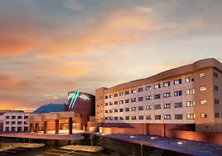

10th Annual Disability Awareness Conference

October 05, 2017

Twin Arrows Casino Hotel & Conference Center

22181 Resort Blvd, Flagstaff, AZ 86004

“We Walk In Beauty, Beyond Our Disabilities”

**Thursday, October 05, 2017**

**9:00 a.m. – 9:45 a.m.**

**Master of Ceremony: Honorable Delegate Johnathan Hale**

**Invocation:** Sylvia McKinley, Vice President

**Welcome Address & NNACOD Initiatives: Hoskie Benally, NNACOD President**

**Presentation:** Cheryl Bates-Harris  **9:45 a.m. – 10:45 a.m.**

**Video Presentation: Beyond and Above our Disabilities’ 10:45 a.m. - 11:15 a.m.**

**Presentation:** Employee’s with Disabilities Rights, Veronika Fabian **11:15 a.m. – 12:00 p.m.**

**Lunch ~ Keynote Speaker: Honorable Delegate Amber Kanazbah Crotty, Navajo Nation Council Delegate 12:15 p.m. – 1:00 p.m.**

Honorary Presentation for Advocate of the year presentation by Hoskie Benally, NNACOD President

Honorary Advocate of the Recipient – Mrs. Treva Roanhorse, NN OSERS Director

**Breakout Presentations 1:10 p.m.-2:00 p.m.**

*a. Your Financial Consumer Rights – Veronika Fabian, Attorney-Choi & Fabian Law Firm*

*b. Disability Employment Disclosure –Hoskie Benally, Community & Gov’t Liaison, & Jessica Jones, Advocate-NADLC*

*c. Accessing & Process of VR Services for State and Tribal Networking – Navajo Nation OSERS*

*d. Work Incentives and Trial Work Experience – Cheryl Bates – Harris*

**General Session: Job Accommodations & Assistive Technology –Clayton Guffey MSW, CRC, ATP, CEAC 2:15 p.m. – 3:00 p.m.**

**AZ Technology Access Program (AzTap)**

*Presentation: Self-Advocacy – Therese Yanan, Executive Director/Attorney-NADLC 3:00 p.m. – 3:30 p.m.*

*Jessica Jones, Advocate*

***Closing Remarks/Evaluations*  3:30 p.m. – 3:45 p.m.**

**Things to remember**

**\*Don’t forget to pick up your lunch ticket**

**\*Complete your evaluations and receive 2018 planner**

The NNACOD & NN OSERS

is honored to provide you FREE continental breakfast and lunch.

|  |  |
| --- | --- |
| *\*BREAKFAST\** | *\*LUNCH\** |

[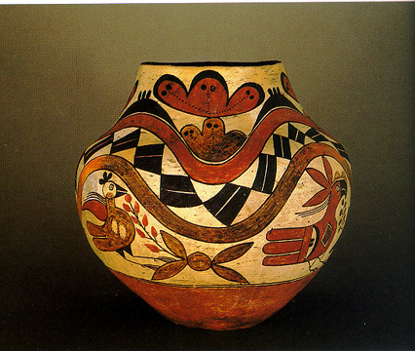](http://www.google.com/url?sa=i&rct=j&q=publeo%20art&source=images&cd=&cad=rja&docid=Mq7ISg-SBJXw4M&tbnid=4_P8JxJDWY9VGM:&ved=0CAUQjRw&url=http://www.ewebtribe.com/NACulture/arthistory.html&ei=NUcOUs-iIcbtiQKF_IHgCw&bvm=bv.50768961,d.aWc&psig=AFQjCNHJtcOqvCHkUKpDzJy3RtzHyEOs_w&ust=1376753768796073)